Project Definition

Project – PRJ601

Southampton Solent University

BSc Software Engineering

Mark Tomlin – Q09947311

PRJ601: Project Definition

# Name

Mark Tomlin

# Title

Website Application using a game server API

# Introduction

This project will be to design and create a web application (app) for a computer game (third-party game app) for the game ‘League of Legends’. The game’s developers (Riot Games Inc.) have released the game servers API for third party developers (see appendix 1). The website will make use of the game developer’s API to retrieve the user’s in-game data. The user’s data will be used for the application to give the user statistics and recommendations for their current game based on the user’s available account data.

# Background

The reason for choosing this project is related to a computer game the author has been playing for the last two years called ‘League of Legends’. The game has received a huge growth in the number of players within the last year “67 million playing every month, 27 million playing every day” (Riot Games Inc., 2014). Due to this and the very high competitiveness of the game, many third party website applications have been created to help players get an edge over their opponent. The author wishes to create his own third party web application for the game.

To understand the function and purpose of the application, the game firstly has to be described to some detail to give context. The game currently features 121 playable characters (‘champions’) that a player can chose to play for each game. There are currently other web-apps for the same game that allow users to enter the character of their opponent. The web-app will recommend a small list of characters to pick for that match, to counter their opponent and gain an edge before the match starts.

The decision to design a web-app came after the author regularly used a few of these already available apps (see appendix 2 for example). While the existing web-apps are very easy to use and functional, there could be a bigger scope for improvement of these applications concept. The plan for creating the web-application involves requesting the user’s opponent’s character and the user’s in game account name. With the account name the app can request previous match data about the player/user from the game server using the game developer’s API. This data can then be used (an example can be characters frequently played by the user) to determine a more personalised character recommendation list for the user. This approach improves the functionality of similar existing applications by making the app function personally for the user.

The decision to create this application as a website is because firstly the user will want to use the application when the user is picking a character for a game. This part is done in the game client application, which is a small desktop application. Because users will already be running a game application on their desktop, the author feels that from user experience that it’s most convenient to run a third party game app in a web browser as opposed to its own desktop application. Secondly it’s already tried and popular approach for majority of all the third party apps for the game, users are already accustomed to using web application for this particular game. Thirdly the author is confident he will be able to write the application as a website using the scripting language JavaScript to be functional “"building full-blown applications in JavaScript is not only feasible, but increasing popular" (MacCaw, 2011).

# Aim

To create a fully functional and responsive web application for players of the game ‘League of Legends’, making use of the game developer’s available API.

# Objectives

* Learn and understand how to use the game API
* Create user and game information database tables
* Design and develop the application
* Design the develop the websites aesthetics and navigation
* Develop dynamic and responsive website interaction
* Create prototype websites for testing (by game player)
* Develop prototype from test user feedback

# Methodology

Taking into account that this will be the author’s first software project, he concluded that choosing a suitable software development process will bring a huge impact into the productivity and development of the project. Upon researching different software development methodologies it has become clear that choosing a software evolutionary/iterative process will suit his project’s circumstances. The reasoning for this is due to his inexperience with creating and developing a whole software project. The requirements specification and design won’t be clear to the author when he first starts the development process. Therefore having a flexible and open to change development methodology is most suited “software evolution is necessary because the domain of software itself evolves, also called the volatility of requirements” (Dorman, 2011).

The author has experience working with an Agile development methodology in a team, so choosing a similar iterative process will be beneficial. Industry standards depicts Agile development as only applicable in teams, however many lone software development professionals argue it can be used effectively for solo projects “agile methodology easily lends itself to rapid application development, even for the solo programmer” (Doll, 2002). For this project the author plans to use Extreme programming (XP) as his development methodology and is a type of agile development. The decision was based on the XP core focuses, these being:

* Continuous Integration
* Test Driven Development
* Simplicity
* Iterative releases

The process reflects quality and responsiveness for any changing requirements, this will be perfect for this project “XP is the practice and pursuit of effective simplicity, as applied to software development” (Advoco Services Inc., 2014). However there is conflict with part of XP’s core practices which is paired programming “software in XP is built by two programmers, sitting side by side, at the same machine.” (Jeffries, 1999-2014). An adapted version of XP will need to be used to keep the methodology’s core focuses, but suitable for a solo software project.

# Risk Analysis

Several risks are prevalent for this project from start-up, a list of potential risks has been written with details of its impact, and likelihood and contingency (see appendix 3 for list). The risks the author thinks have highest potential for failure or derailment of the project are risks 1 & 4, both with a high impact and medium probability. These two risks involve the solving the functionality of the application and both are relatively probable because solution is unknown to the author currently. There are counter measures listed for both however they still impact the entire functionality of the application.

Other risks that are unique to this project are risks 2, 10, 11 & 12. The reliance of the API and game servers being available brings huge impact to the functionality of the application. However risks 2, 11 & 12 are unlikely because over past year Riot Games (game and API owner) has shown encouragement towards third party developers and API usage “We work with everyone from big companies like Curse all the way down to little 2 man teams working out of a dorm room, and work to grow and encourage the developer community with all of them” (Riot Sargonas, 2014). Risk 10 is very likely to happen because the game servers are regularly updated by the developers. So any server maintenance or updates will render the server temporarily unavailable. Therefore an offline result for the application will be needed for whenever a server is unavailable.

# Software Resources

* HTML5
* Notepad++
* FileZilla
* phpMyAdmin
* PHP
* SQL
* XML / JSON
* AJAX
* jQuery
* JavaScript
* Riot Games API
* Google Chrome / Mozilla Firefox / Microsoft Internet Explorer

# References

Advoco Services Inc. (2014). *Solutions: Methodologies* [online][viewed 14 November 2014]. Available from: Advoco Services Web site: http://www.advoco-services.com/methodologies/

Doll, S. (2002). Agile programming works for the solo developer [online][viewed 13 November 2014]. Available from: http://www.techrepublic.com/article/agile-programming-works-for-the-solo-developer/

Dorman, C. (2011, January). *An experience report of the solo iterative process.* Detroit: Wayne State University Theses.

Jeffries, R. E. (1999-2014). *What is extreme programming* [online][viewed 14 November 2014]. Available from: http://xprogramming.com/what-is-extreme-programming/#pair

MacCaw, A. (2011). JavaScript Web Applications. In A. MacCaw, *JavaScript Web Applications* (p. 1). San Francisco: O'Reilly Media.

Riot Games Inc. (2014). *Riot Games: Developers* [online][viewed 9 November 2014]. Available from: https://developer.riotgames.com/

Riot Games Inc. (2014). *Riot Games: Our Games* [online][viewed 13 November 2014]. Available from: http://www.riotgames.com/our-games

Riot Sargonas. (2014). *League of Legends: Forums: General Discussion* [online][viewed 14 November 2014]. Available from: http://forums.na.leagueoflegends.com/board/showthread.php?p=45816583#post45816583

SoloMid Network. (2011-2014). *League of Legends Counter* [online][viewed 13 November 2014]. Available from: http://www.lolcounter.com/

# Appendices

## Appendix 1 – Riot Games API Webpage



Figure 1 - https://developer.riotgames.com/

From the game’s company webpage (Riot Games Inc., 2014) it allows third party developers access to the game server’s API. From this webpage you can also learn how to use the API including parameters and data returned.

## Appendix 2 – Analysis of similar web application

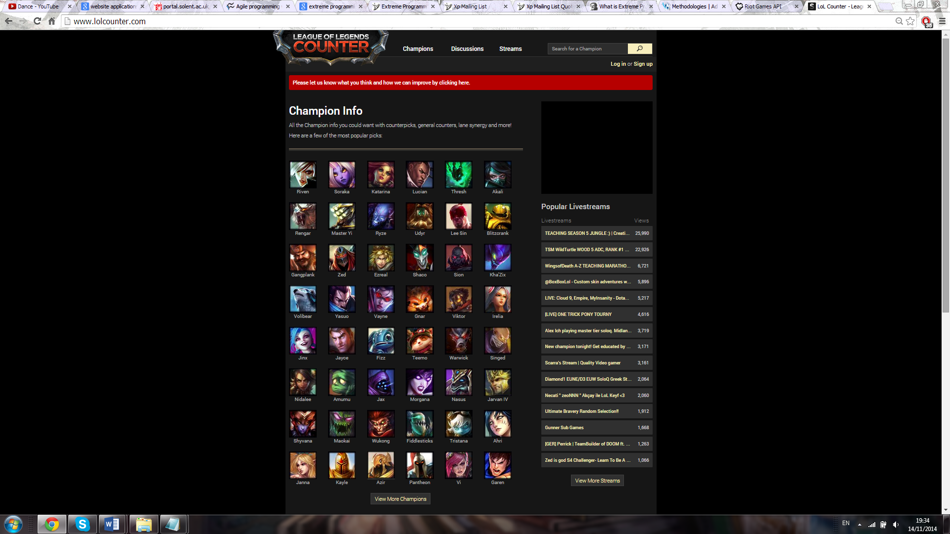

Figure 2- home page - <http://www.lolcounter.com/>

Figure 2 shows the first page of similar web app (SoloMid Network, 2011-2014). This page allows users to select a character/champions they are playing against for information on how to gain an upper hand (counter).

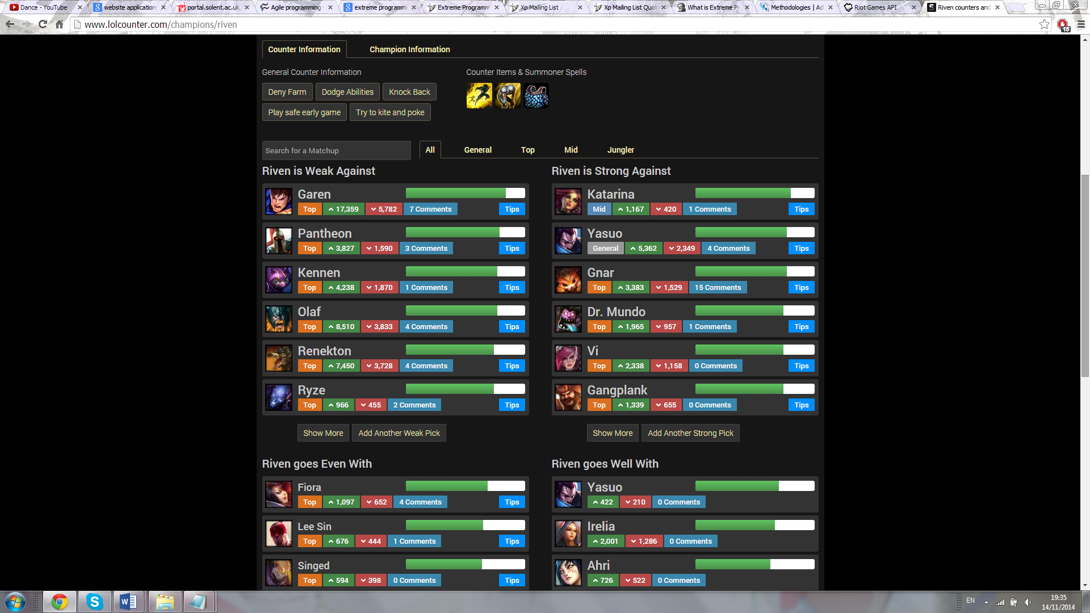

Figure 3- Champion page - <http://www.lolcounter.com/champions/riven>

Figure 3 shows information about how to beat a selected character/champion. The main piece of information desired is the character listings of who is weak and/or strong against them. The listing on this website is done by user voting (agree or disagree). Additional game information is displayed, along with user comments for detailed explanations.

## Appendix 3 – Risk Table

|  |  |  |  |
| --- | --- | --- | --- |
| Risk | Impact | Probability | Contingency |
| 1. Unable to solve functionality of the application | High | Medium | Change or reduce the functionality of the application |
| 1. Game developers restrict the use of their server API | High | Low | Change the function of the application |
| 1. Project data loss | High | Low | Multiple back-up save locations |
| 1. Unable to join characters in database for listing | High | Medium | Learn from similar existing applications |
| 1. Inefficiency with XP based methodology | Medium | Medium | Adapt to a agile based methodology |
| 1. Database scalability with characters | Low | Low | Separate attributes into different tables or a separate database. |
| 1. Compatibility with multiple web browsers | Low-Medium | Medium | Learn and fix any important compatibility elements |
| 1. Copyright issues with game’s company (i.e. Art use) | Medium | Low | Use open source or self-created resources |
| 1. Failure to comply with Data Protection Act | Medium | Low | Restrict personal data collected from registered users |
| 1. Game servers offline or unavailable | Medium | High | Redirect to user generated character listings while offline |
| 1. Failure to comply with Riot Games API terms & conditions | High | Low | Change the function of the application |
| 1. Failure to comply with Riot Games third party application policies | High | Low | Change the function of the application |

## Appendix 4 – Risk Resolution Phase schedule

|  |  |  |  |
| --- | --- | --- | --- |
| Task | Est. hours | Completed by | Milestone? |
| Plan | 2 | November |  |
| Project Spec. | 4 | December | Yes |
| Risk mitigation 1-6 | 5 | December |  |
| Risk mitigation 6-12 | 5 | December | Yes |
| Methodology | 3 | January |  |
| Iteration Plan | 2 | January | Yes |

## Appendix 5 – Ethics Release Form

